**The A Collective: History**

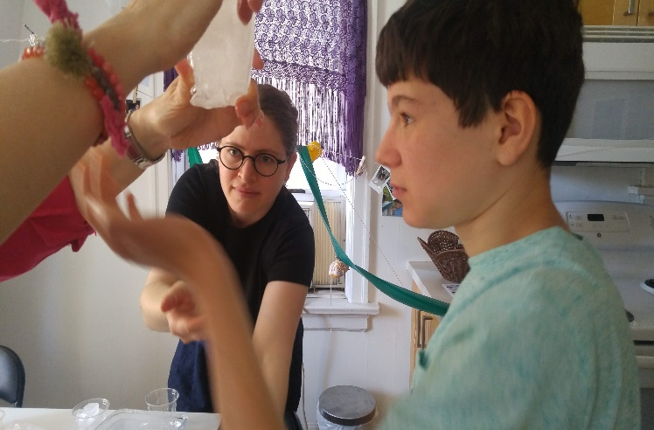The A Collective has emerged over time with ongoing exclusion of neurodivergent people in education and communal life. It is an outgrowth of The A School which was formed in 2016 as a creative school as a result of exclusion and shifted towards an artistic-philosophical curriculum aimed at discovering and supporting the conditions for neurodiversity to emerge and thrive. We become neurodiverse together, with an interdisciplinary group and approach to knowledge and also, for research creation and for work in creative pedagogical approaches. We are located in Toronto, Canada, originally co-founded by Estée Klar and Adam Wolfond, and proliferated by the A Collective group. Estée and Adam are mother and non-speaking autistic son, and have published the dissertation Neurodiversity in Relation: an artistic intraethnography at York University. Estée holds a PhD in Critical Disability studies, supported by the prolific thoughts and publications by Adam Wolfond and also, the collaboration with the participants at The A Collective which consist of other non-speaking people who type to communicate, educators, artists, poets and people who identify as neurodiverse or neurodivergent. The Collective emerged also from participating at SenseLab with Erin Manning and Brian Massumi at Concordia University in Montreal, Canada. Their interest in relational art, philosophy and neurodiversity synchronized with our work in Toronto, that is, processual thinking and working together to find our own way of thinking and creating, together. Estée was awarded a SSHRC grant to complete the film S/Pace with Adam and the A Collective, and her former training as an artist and curator has brought other artists/mentors to also think with neurodivergent people to co-create and think more deeply about contribution and collaboration in order also to create supportive networks of care. The Collective grew to include younger participants who do not typically have access to self-determination with support. We view agency in this regard as collaborative. We are never unto ourselves but are mutually supported in a network of collective care that enables what we call *agencement* rather than agency.

The A Collective emerged from Klar’s work in creative schooling after becoming frustrated at ongoing exclusion of Adam. Schools would not allow his personal and communication support assistant in the classroom. In the public system in Toronto, it was a union issue in that only Educational Assistants were to provide the support, which removed the relational and training component of communication support (no EA is trained in facilitated communication or supported typing and AAC in general). We learned that relational support was also essential for navigating the many transitions and movements within the school environment, yet, EA’s were mostly temporary, and rotated among children. There was no permanence to individualized support. With a culture that supports ABA or IBI in Canada, the emphasis was on making the autistic person as independent as possible, thereby denying access to education in the meantime with the promise that this behavioural therapy would remediate. This remediation had to achieve these goals before inclusion into the classroom – before access to education was granted.

We also noticed that the linear development model, born in the 1800’s to regulate education like a pipeline to factory work, began to create the assumption of normality, leading to the development of structural and systemic neurotypicality. That is, if you were diverse in any way, and could not follow developmental timelines, you were considered delayed, disorded, disabled. The social construction aspect of disability was enacted through the system of education and many were left behind – in institutions and later, into segregated school settings which is just another form of institutionalization. While the public education system created a tributary of special education, after the age of 21, many with disabilities were sent to the institutions and group homes anyway.

Being an artist, Estee learned early about not belonging. The arts were never valued, except as entertainment, and unless popularized entertainment, largely underpaid. However, the arts accessed another mode of expression and communication outside of economic value-profit models. This became a way of thinking in non-economic, neoliberalized terms, as well as for people who made diverse contributions to society.

Looking to the creative schooling model when she established The A School, located in Forest Hill Village in Toronto mainly for Adam, she had a vision to enact caring and creative pedagogies that supported neurodiverse ways of movement and expression. Rather than thinking of this as accommodation and access practices alone, these became autistic-led practices that emerged in relation with objects, with other people, within spaces that revealed how spaces are apprehended and perceived, and how movement processes helped the body to settle within them. The tables and chairs dissapeard and on-the-floor couches and pillows took over. Lap desks replaced table surfaces.

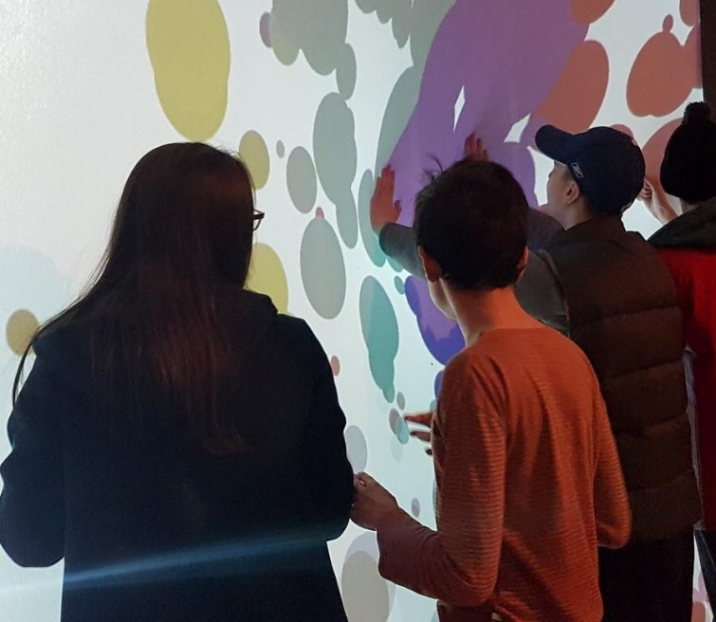

**Assembly: A Laboratory for Neurodiverse Experimentation for Relation**

**We are**

a collaborative learning and supportive assemblage dedicated to neurodiversity and shifting research creation and knowledge

**We begin**

with the premise that experimentation and process is at the heart of experience and collaboration, we attune to the conditions that support and proliferate neurodiversity

**We move**

between philosophy, language and art for relanguaging and conception of neurodiverse movement and pace through relation, affect and materials (what we have named *relationshapes*)

**What moves us**

diversity and relation bringing art, philosophy, critical disability studies together to rethink new modes of life and new forms of value

**Who it addresses**

**•**  all ages and any level of education, neurodiverse or neurotypical who wish to engage in mutual support and learning as a life-long process of social engagement

• for those interested in networks of sustainability for support, education, care

• students and teachers looking for a transdisciplinary, neurodiverse milieu to supplement their studies and interested in learning explorative techniques

• community workers, caregivers, supporters, artists, teachers and activists wishing to explore neurodiversity and collaborative creation to expand their domain of practice

**Keywords:**

Relation, Neurodiversity, Research-Creation, Sustainability, Conviviality, Process

ANTI-MISSION STATEMENT:

~~The A Collective exists as a creative collaborative space where relation is at the core of study for the purposes of shifting disability and inclusion policy in Canada. We utilize arts-based methods for creative works inventing with neurodiversity. We work towards the enactment of inclusion, rethinking how inclusion has been deployed in Canada, revolving around existing normative systems. We provide social groups, reading groups and alternative learning strategies informed by autistic people.~~